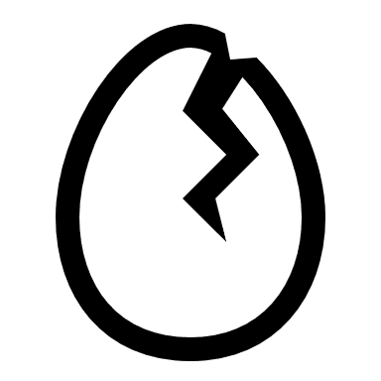Farm Fresh Data

ERD Diagram:  
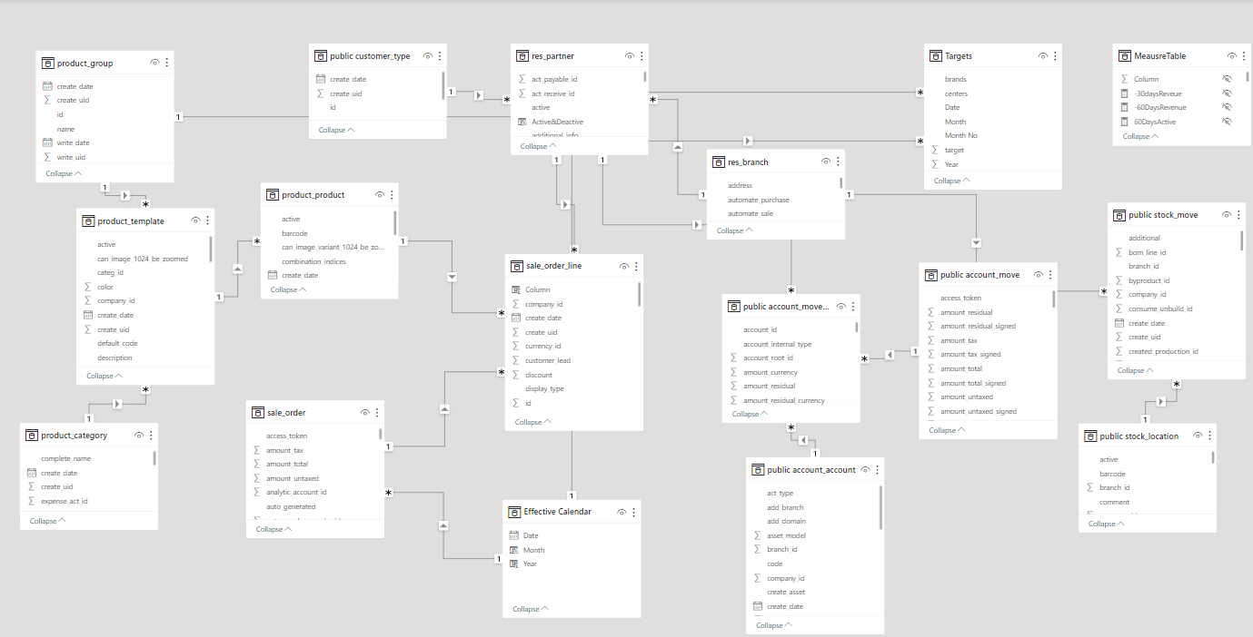

The tables used in Farm Fresh Data are:

1. Product_Group
2. Product_Template
3. Product_Category
4. Product_Product
5. Public_Customer_Type
6. Res_Partner
7. Sale_Order_Line
8. Sale_Order
9. Res_Branch
10. Effective_Calendar
11. Public_Account_Move_Line
12. Public_Account_Account
13. Public_Stock_Move
14. Public_Stock_Location
15. Public_Account_Move
16. Targets
17. Measures_Table

Now below is the description of each table mentioned above:

1. **Product_Group:**  
   This table contains information about which egg’s type group we have. It has an ID column which is joined with ***Product_Template*** table and name column which is joined with Targets table.  
   Following are the useful columns of this table.

|  |  |
| --- | --- |
| ***ID*** | This contains numeric values that are assigned to each group uniquely. |
| ***Name*** | Text value that shows the product group. |

1. **Product_Template:**  
   This table contains information about which type of egg packaging we have. It has an ID column which is joined with ***Product_Group*** table, ***Product_Category*** table and ***Product_Product*** table.  
   Following are the useful columns of this table.

|  |  |
| --- | --- |
| ***ID*** | This contains numeric values that are assigned to each template uniquely. |
| ***Name*** | Text value that shows the product group. |
| ***Group_ID*** | Numeric values that come from Product_Group table. |
| ***Category_ID*** | Numeric values that come from Product_Category table. |

1. **Product_Category:**  
   This table contains information about what type of product’s category are we selling whether it’s Open or Brand. It has an ID column which is joined with ***Product_Template***.  
   Following are the useful columns of this table.

|  |  |
| --- | --- |
| ***ID*** | This contains numeric values that are assigned to each category uniquely. |
| ***Name*** | Text value that shows the product category. |

1. **Public_Customer_Type:**  
   This table contains information about which type of customer are we selling whether it’s Retail or institutes. It has an ID column which is joined with ***Res_Partner*** table.  
   Following are the useful columns of this table.

|  |  |
| --- | --- |
| ***ID*** | This contains numeric values that are assigned to each customer uniquely. |
| ***Name*** | Text value that shows the customer type. |

1. **Product_Product:**  
   This table contains information about which egg’s product we are selling. It has an ID column which is joined with ***Product_Template*** table and ***Sale_Order_Line*** table.  
   Following are the useful columns of this table.

|  |  |
| --- | --- |
| ***ID*** | This contains numeric values that are assigned to each product uniquely. |
| ***Product_templ_id*** | Numeric value that comes from Product_Template table |

1. **Sale_Order:**  
   This table contains transactional information. It has an ID column which is joined with ***Sale_Order_Line*** table and effective date is joined with ***Effective_Calendar*** table.  
   Following are the useful columns of this table.

|  |  |
| --- | --- |
| ***ID*** | This contains numeric values that are assigned to each transaction of sales uniquely. |
| ***Effective_date*** | Date that shows the sale’s date. |

1. **Res_Partner:**  
   This table contains information about the shops that we are connected with. It has an ID column which is joined with ***Public_Customer_Type*** table, ***Res_Branch*** table, ***Public_Account_Move_Line*** and ***Sale_Order_Line*** table.  
   Following are the useful columns of this table.

|  |  |
| --- | --- |
| ***ID*** | This contains numeric values that are assigned to each shop uniquely. |
| ***Name*** | Text value that shows the shop’s name. |
| ***Customer_type_id*** | Numeric values that come from customer_type table. |

1. **Sale_Order_Line:**  
   This table contains transactional information. It has an ID column which is joined with ***Product_Product*** table and ***Sale_Order*** table.  
   Following are the useful columns of this table.

|  |  |
| --- | --- |
| ***ID*** | This contains numeric values that are assigned to each sale’s detail uniquely. |
| ***Product_id*** | Numeric values that come from product_product table. |
| ***Order_id*** | Numeric values that come from sale_order table. |
| ***Order_partner_id*** | Numeric values that come from res_partner table. |
| ***Untaxed_amount_invoiced*** | Shows us the revenue |
| ***Return_amount*** | Shows us how much has been returned in terms of amount. |
| ***Return_volume*** | Shows us quantity of eggs returned |
| ***Volume_sold*** | Shows us quantity of eggs sold |

1. **Effective_Calendar:**  
   This table contains information about date. It has a Date column which is joined with ***Sale_Order table*** and ***Targets*** table.  
   Following are the useful columns of this table.

|  |  |
| --- | --- |
| ***Date*** | This contains date that comes from sale_order table. |

1. **Res_Branch:**  
   This table contains information about that centers/branch that we currently have. It has an ID column which is joined with ***Res_Partner*** table and ***Public_Account_Move*** table.  
   Following are the useful columns of this table.

|  |  |
| --- | --- |
| ***ID*** | This contains numeric values that are assigned to each branch uniquely. |
| ***Name*** | Text value that shows the branch’s name. |

1. **Public_Account_Move_Line:**  
   This table contains information about the opening balance. It is joined with ***Res_Partner*** table, ***Public_Account_Account*** table and ***Public_Account_Move*** table.  
   Following are the useful columns of this table.

|  |  |
| --- | --- |
| ***ID*** | This contains numeric values that are assigned to each account transfer uniquely. |
| ***Move_name*** | Text value that shows the name of account transfer. |
| ***Move_id*** | Numeric values that come from Account_move table. |
| ***Partner_id*** | Numeric values that come from Res_partner table. |
| ***Account_id*** | Numeric values that come from Account_account table. |

1. **Public_Account_Account:**  
   This table contains information about the opening balance. It is joined with ***Public_Account_Move_Line*** table.  
   Following are the useful columns of this table.

|  |  |
| --- | --- |
| ***ID*** | This contains numeric values that are assigned to each account transfer uniquely. |
| ***Name*** | Text value that shows the name of account transfer. |
| ***Reconcile*** | Boolean values that are used in calculating opening balance. |

1. **Targets:**  
   This table contains information about monthly volume patti sold that is set as targets for each center and brand. It has a Date column which is joined with ***Effective_Calendar*** table and brand column which is joined with ***Product_Group*** table.  
   Following are the useful columns of this table.

|  |  |
| --- | --- |
| ***Date*** | This contains the date. |
| ***Centers*** | It contains branch values. |
| ***Brands*** | It contains product_group values. |
| ***Target*** | It contains the specific target value (Volume to be sold per patti) |

1. **Public_Account_Move:**  
   This table contains information about the opening balance as well. It has an ID column which is joined with ***Public_Account_Move_Line*** table.  
   Following are the useful columns of this table.

|  |  |
| --- | --- |
| ***ID*** | This contains numeric values that are assigned to each account move uniquely. |

1. **Public_Stock_Move:**  
   This table contains information from where the eggs have been transported which center to which and whether the transfer is internal or not. It is joined with ***Res_Branch*** table and ***Public_Stock_Location*** table.  
   Following are the useful columns of this table.

|  |  |
| --- | --- |
| ***ID*** | This contains numeric values that are assigned to each stock movement uniquely. |
| ***Branch_id*** | Values that come from res_branch table. |
| ***Location_dest_id*** | Numeric values that indicate location id to which center the movement has been done. |
| ***Loctaion_id*** | Numeric values that indicate location id to which center the movement has been made from. |
| ***Product_id*** | Numeric values that come from Product_product table. |

1. **Public_Stock_Location:**  
   This table contains information from where the eggs have been transported which center to which and whether the transfer is internal or not. It is joined with ***Public_Stock_Move*** table.  
   Following are the useful columns of this table.

|  |  |
| --- | --- |
| ***ID*** | This contains numeric values that are assigned to each stock movement’s detail uniquely. |
| ***Name*** | Text values that indicate the center. |
| ***Usage*** | Text values that show which type of movement has been made. |
| ***Branch_id*** | Numeric values that indicate that center’s name branch id. |

1. **Measures_Table:**  
   This table contains measures that are used till now. Following is its detail.

|  |  |
| --- | --- |
| ***Achieved%*** | % of volume patti sold that we have hit in comparison to targets. |
| ***Active Shops*** | Shops that have any sale in last 30 days. |
| ***Brand Classic Revenue*** | Revenue of classic brand |
| ***Brand Golden Revenue*** | Revenue of golden brand |
| ***Brand Omega Revenue*** | Revenue of omega brand |
| ***Brand Sales*** | Revenue of three brands |
| ***Classic%*** | Revenue % of classic brand |
| ***Golden%*** | Revenue % of golden brand |
| ***Inventory*** | Inventory in stock for Lahore Center |
| ***Omega%*** | Revenue % of omega brand |
| ***Open Sale*** | Revenue of open eggs |
| ***Open Sale Ratio*** | Revenue % of open sale |
| ***Opening Balance*** | Difference of debit & credit in account |
| ***Return Amount*** | Sum of return number of eggs |
| ***Return%*** | % of eggs volume returned |
| ***Revenue*** | Sale of eggs |
| ***Revenue MoM%*** | Revenue on Month over Month |
| ***Revenue YoY%*** | Revenue on Year over Year |
| ***Selected Shop*** | Shows the shop we have selected in “Shops” page |
| ***Shops*** | Total distinct shops we have |
| ***Sold patti by classic*** | Volume of patti eggs sold in classic brand |
| ***Sold patti by omega*** | Volume of patti eggs sold in omega brand |
| ***Sold patti by golden*** | Volume of patti eggs sold in golden brand |
| ***UOM*** | Unit of stock quantity moved in stocks table |
| ***Volume sold*** | Volume of eggs sold |
| ***Volume sold patti*** | Volume of patti of eggs sold |

Here’s the link to the files:

<https://drive.google.com/drive/folders/1_T4JsNXJGtNrjszo0td8E8HIC6y0J5rr?usp=sharing>